**Club Activities**

1. **Induction Program :-for S.Y and F.Y**

Team Mechagrinics recently organized an impactful induction program for first-year participants, aimed at introducing them to the team's mission and their involvement in the upcoming TIFAN competition by SAE India, focusing on automation in agriculture. The program included insightful sessions on the significance of agricultural automation, technical insights into sensor integration and control systems, and an introduction to the project scope for TIFAN. Emphasizing a culture of collaboration and mentorship, the induction successfully ignited enthusiasm among new members, fostering a shared commitment to excel in the competition and contribute to the innovative field of automation in agriculture.

Top of Form

1. **John Deer Visit for team participation:-**

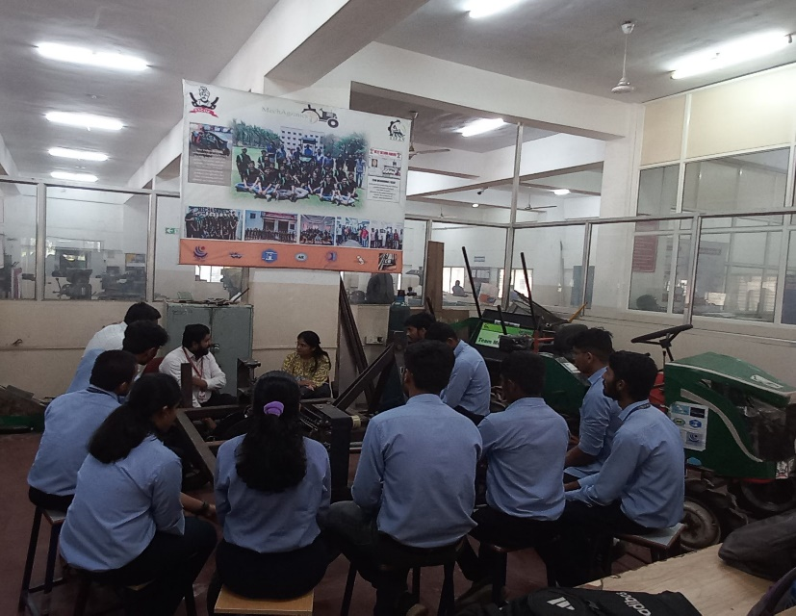The mechAgrinics club honored to host a visit from **John Deer** representatives ,focusing on potential team participation in upcoming **TIFAN competition** .The purpose of the visit was to explore collaborative opportunities and solidify plans for joint involvement in the prestigious event.

The agenda included in depth disscusions about the competitions requirements,showcasing MechAgrinics relevant projects,and aligning our expertise with John Deer objectives for the TIFAN competition.

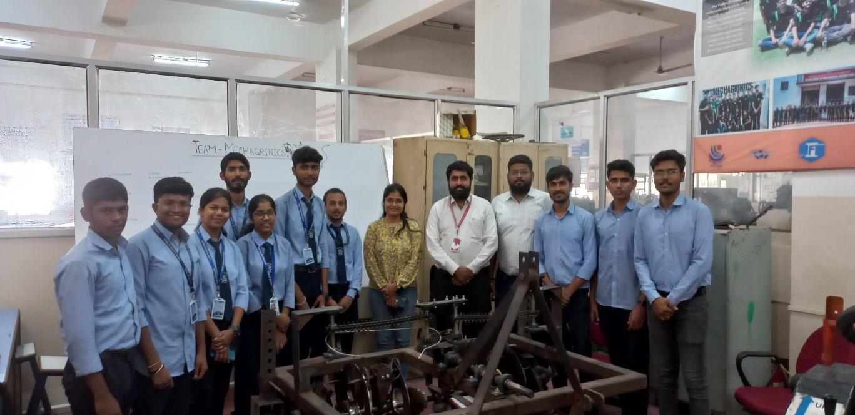

The outcome was highly positive,with a shared enthusiasm for collaborative efforts and a commitment to forming a competitive team . Plans are now underway to harness the unique blend of mechanical and agri-tech expertise within MechAgrinics to create an impactful and innovative presence in the upcoming TIFAN competition.

1. Top of Form
2. **Unlocking prosperity: “Your Gateway to financial improvement with TIFAN check-in-hand”:-**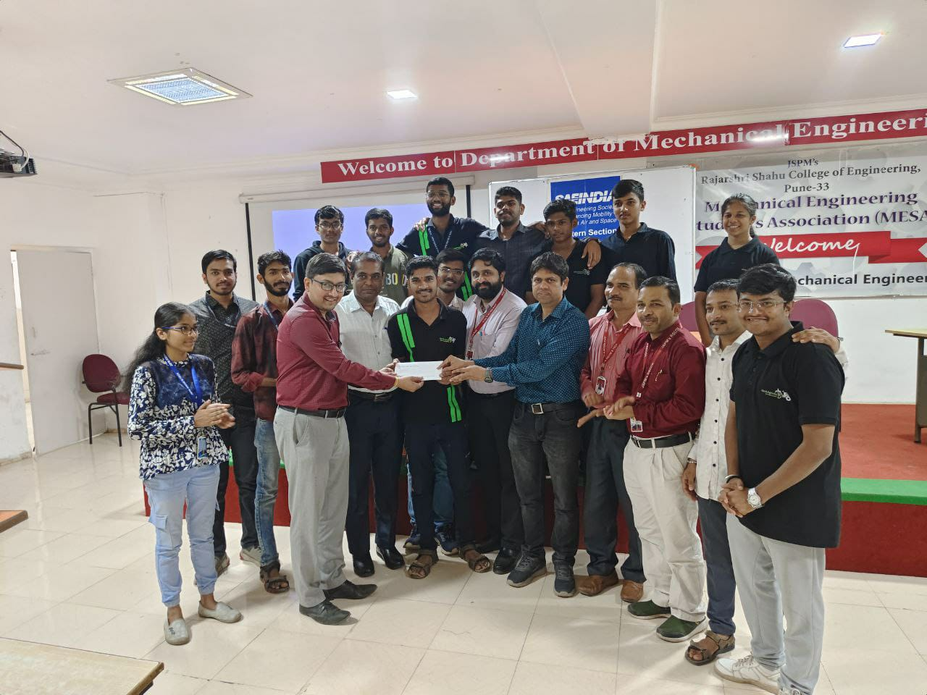After clinching the Best cost economy award, In The TIFAN competition, we were honored to receive a commendation in the form of the check from SAE India.

The award ceremony, showcased our exemplary cost-saving initiatives and innovative approaches to resource utilization. We proudly received a prestigious award check during the ceremony, symbolizing our dedication to economic excellence. This achievement not only enhances our organization's industry standing but also motivates us to continue implementing sustainable and cost-effective strategies for long-term success. We extend our gratitude to the award organizers and commend the collective efforts of our team members that made this accomplishment possible.

Top of Form

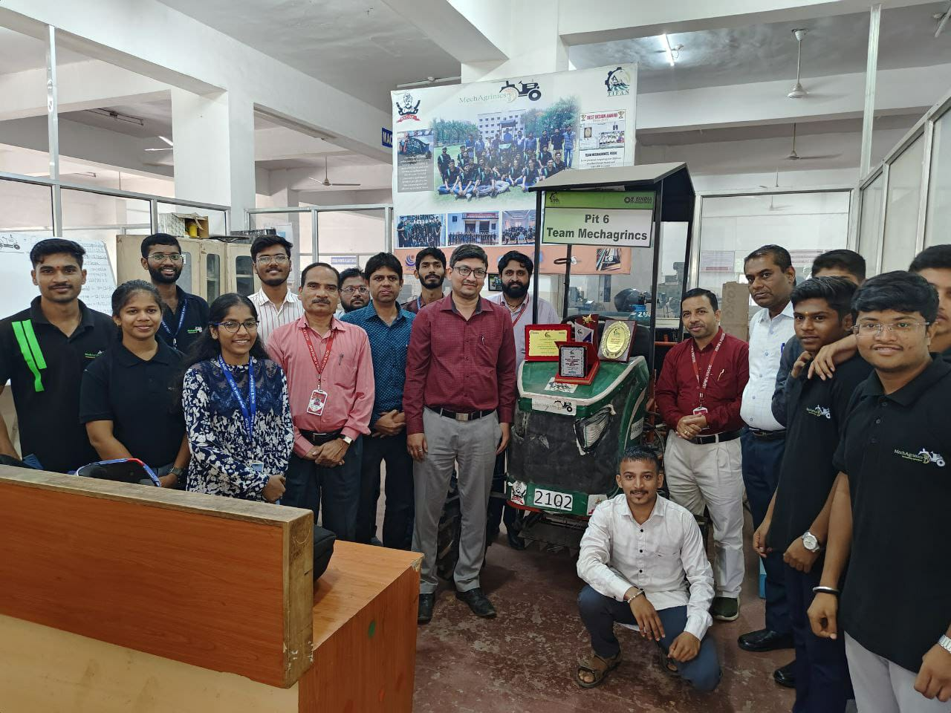

1. **First prize Triumph in vasundara kirloskar idea challenge**

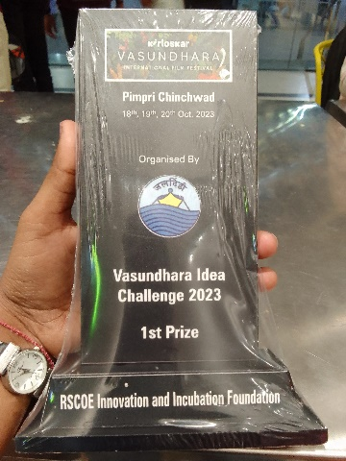We are delighted to announce that our project , Automated multi-vegetable transplanter secured the first prize in of Vasundara Kirloskar Idea challenge. Transplanter utilizes the automation technology to enhance the planting accuracy and efficiency also helps to reduce the labour cost.

During Award ceremony we get oppourtunity to meet India’s first Paralympic gold medallist,**Murlikath petkar**! His achievements and resilience are truly inspiring. He share his life incidents and valuable experience with us.

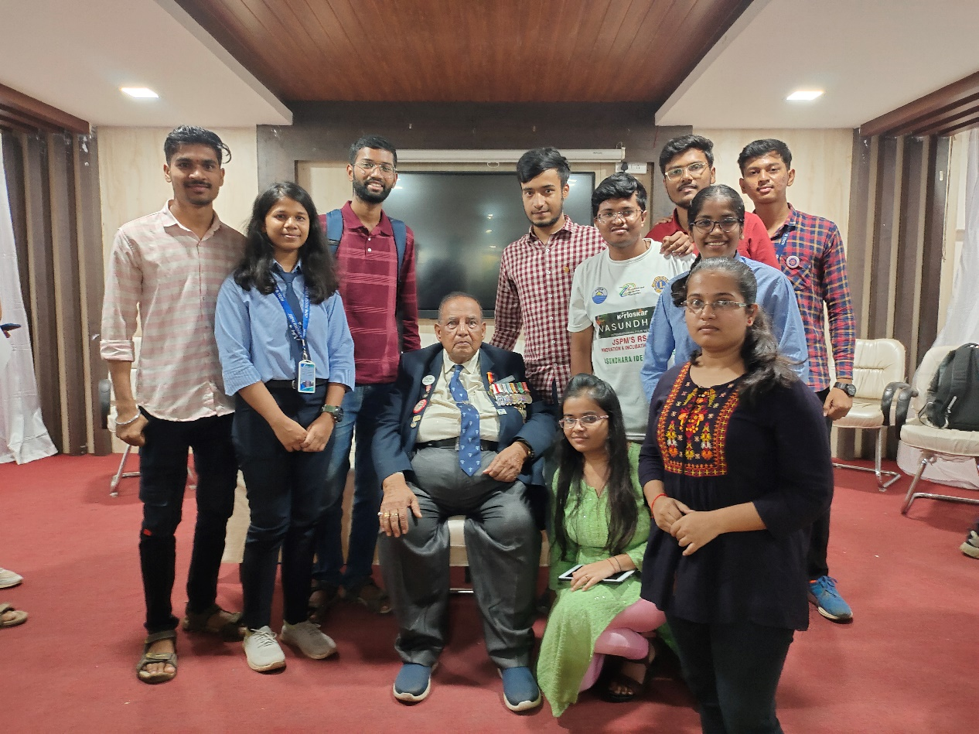

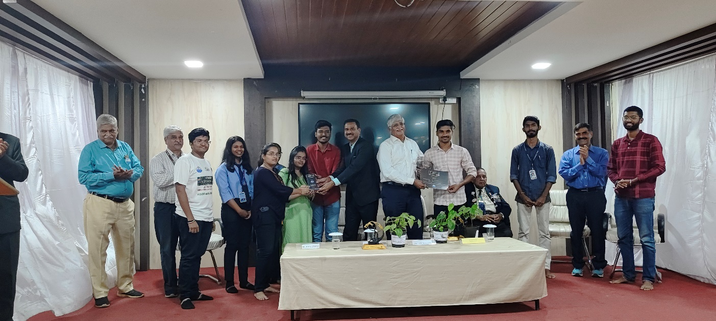 We are grateful for the opportunity and motivated to further develop and implement our Automated Multi-Vegetable Transplanter, contributing to the future of sustainable and technologically advanced agriculture.

1. 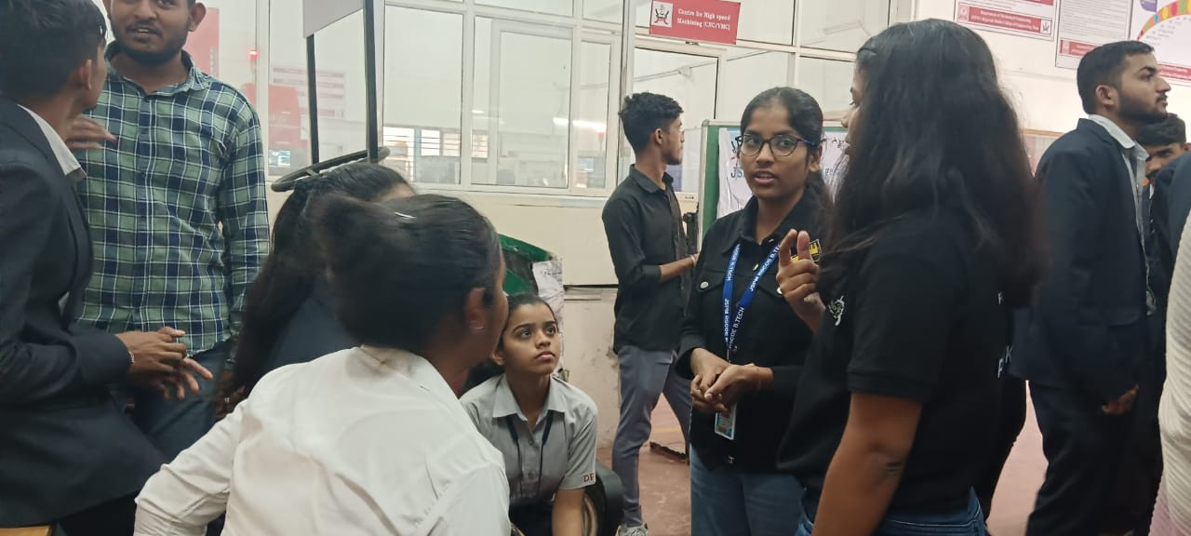**Newly established D.Y Patil Pimpri Team Visit:-** Our team recently hosted D.Y Patil College newly established team , offering guidance for their participation in TIFAN Compitition The enthusiastic D.Y Patil Team , gearing up for the event, received insights on competition structure,team roles,design strategies, documentation, and more.

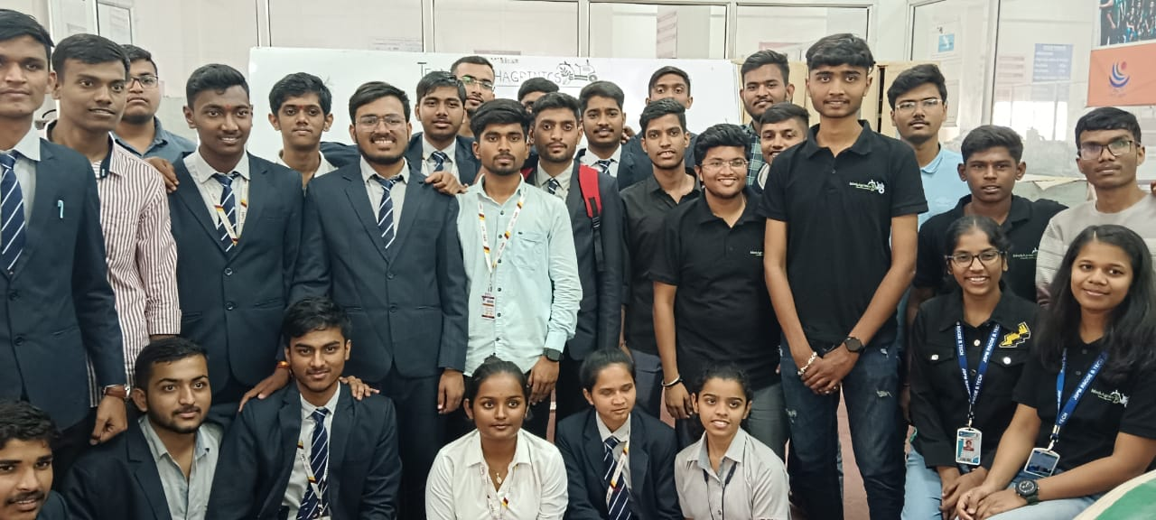Wishing them the best in their preparation and looking forward to seeing their innovation shine in the competition.

1. **Attended Technical Workshop organise by SAE India:-**

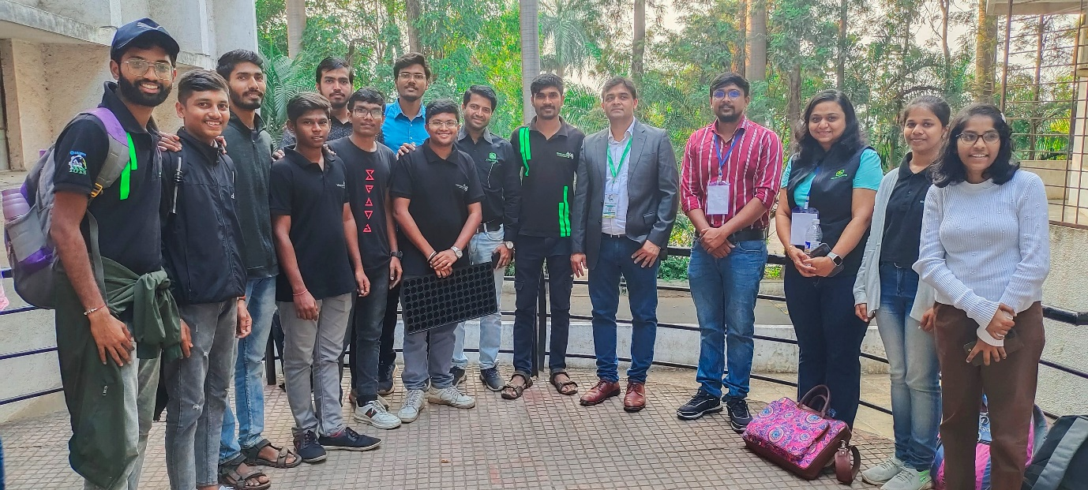 Our team participated in a technical workshop organized by SAE India, focusing on the implementation of an automated multi-vegetable transplanter. The workshop covered key aspects such as system architecture, Mechanism mounting,Digging Mechansim,Power transmission, and key points to design a product.

On November 25th, we had the privilege of meeting our co-mentor, Krushna kalatre Sir, whose valuable guidance and support bolstered our confidence in approaching the project. This workshop equipped us with the necessary tools and knowledge to contribute to the advancement of agricultural technology, and we express our gratitude to SAE India and Krushna kalatre Sir for this enriching experience.

**8)** **Farm Visit and Agricultural Survey :-**

On 3rd Dec, Our team conducted a survey at Pradeep Darshile's farm, focusing on the cultivation needs of crops such as tomatoes, brinjals, and a variety of vegetables.

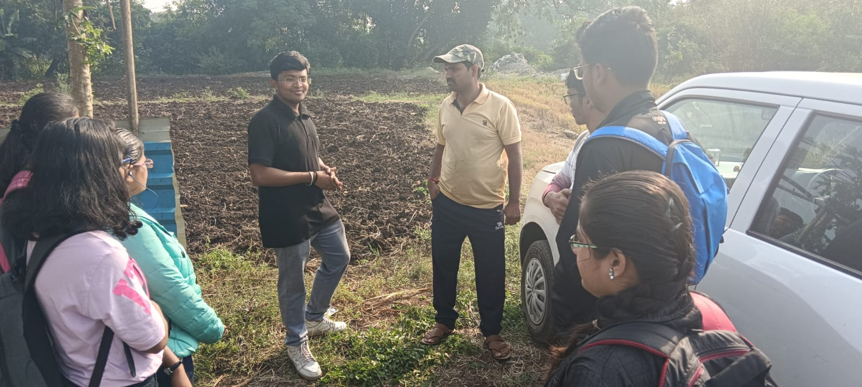

The visit revealed a diverse crop portfolio, varying soil conditions, and distinct water management challenges. Leveraging insights gathered from interviews with Mr. Darshile and discussions with farm worker, we propose the integration of a multi-vegetable transplanter as a valuable solution. This technology aims to optimize planting efficiency, enhance crop yield, and contribute to overall farm sustainability. Recommendations include crop-specific planting techniques, water-efficient irrigation, and integrated pest management strategies, with the multi-vegetable transplanter serving as a key enabler for streamlined and efficient agricultural practices.

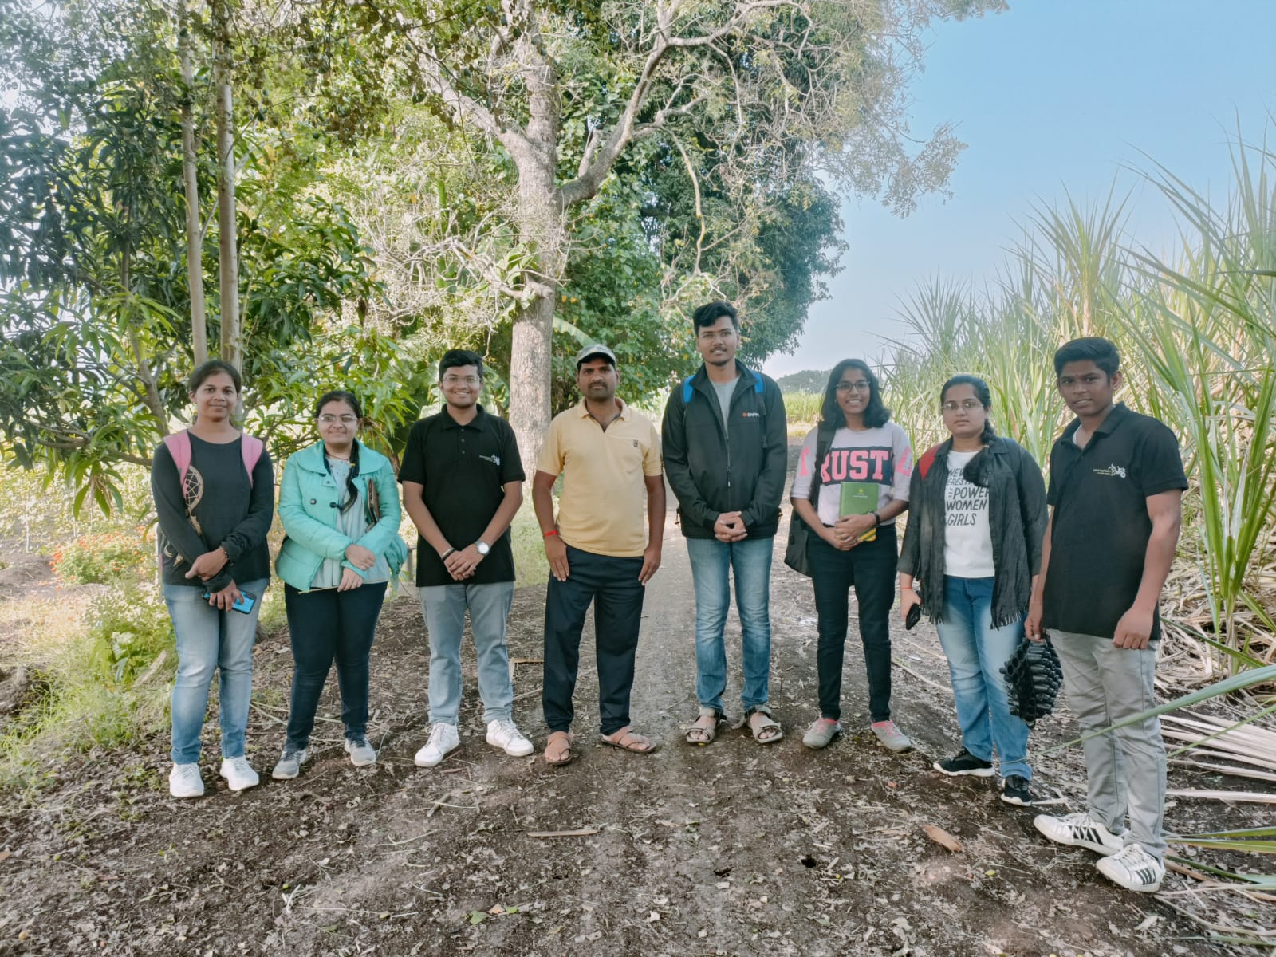 This collaborative effort aims to enhance the farm's productivity and sustainability while contributing to the broader advancement of agricultural practices.

**9) EV Expo 2023 at Auto Cluster Exhibition Center, Pune:-**

Our team attended the EV Expo 2023 at the Auto Cluster Exhibition Center in Pune, where the forefront of electric vehicle (EV) technology was on display. The expo featured a diverse range of electric vehicles, from two-wheelers to commercial vehicles, highlighting advancements in battery technology and charging infrastructure. Industry experts provided insights into the evolving landscape of sustainable mobility, emphasizing collaborative efforts and policy frameworks.

The EV Expo 2023 at the Auto Cluster Exhibition Center in Pune provided a comprehensive overview of the latest trends and innovations in the electric vehicle industry. The event showcased the industry's commitment to sustainability, technological advancements, and the continued growth of electric mobility. Our team gained valuable insights into the evolving landscape of electric vehicles, contributing to our understanding of the opportunities and challenges in this dynamic sector.

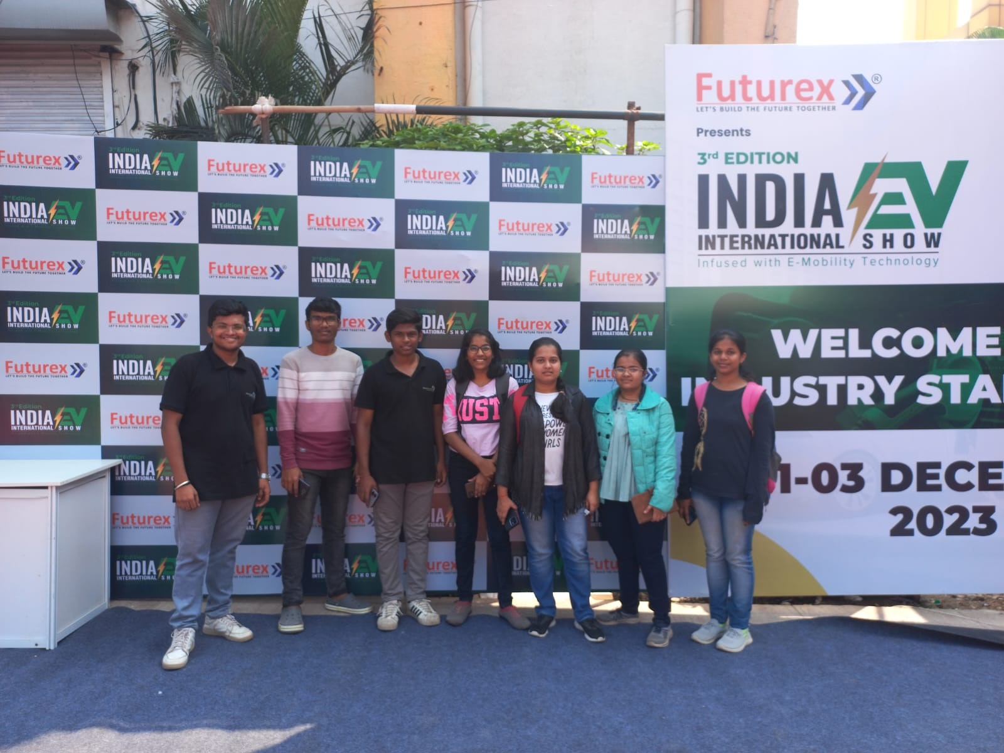

Networking opportunities allowed for valuable exchanges with manufacturers and experts, contributing to our understanding of the dynamic and growing electric vehicle industry.

Top of Form

**10) Kisan Expo 2023 : Cultivating Innovation in Pune’s Agricultutral Landscape:-**

The Kisan Expo 2023 in Pune emerged as a pivotal event, uniting stakeholders in agriculture to unveil cutting-edge advancements and innovations. With a focus on fostering collaboration, the expo provided a dynamic platform for farmers, agribusiness professionals, and industry experts to exchange ideas and explore emerging trends.

Hosted at Moshi, the event showcased a diverse range of exhibitors, from agricultural machinery manufacturers highlighting state-of-the-art equipment to seed companies emphasizing improved varieties.

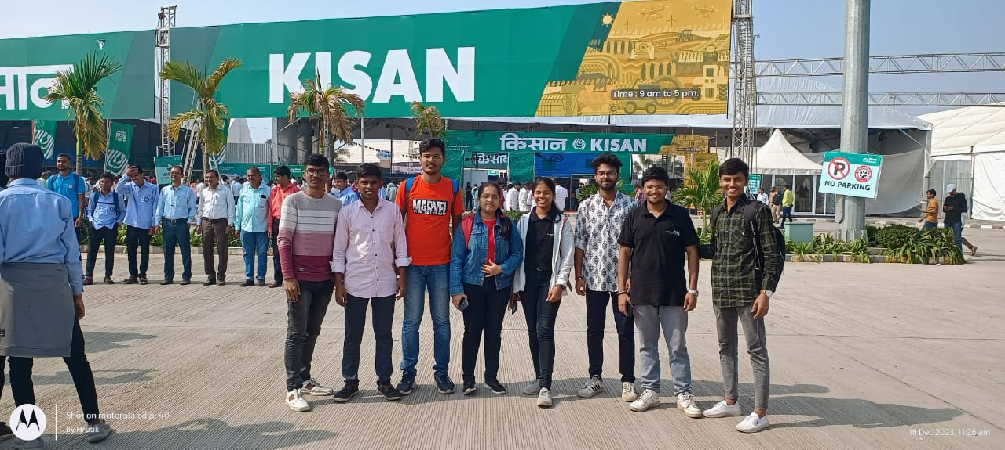

Agrochemical companies underscored environmentally sustainable solutions, while technology providers presented innovations such as precision farming tools and data analytics. Our visit to the expo proved enlightening, offering valuable insights into the forefront of modern farming practices and reinforcing the importance of staying abreast of industry trends.

Top of Form

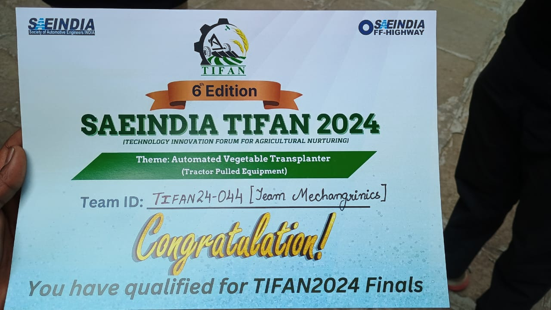**11) Hard work pays off! Qualified for TIFAN finals after a journey of dedication and teamwork. Ready to conquer the next challenge! :-**

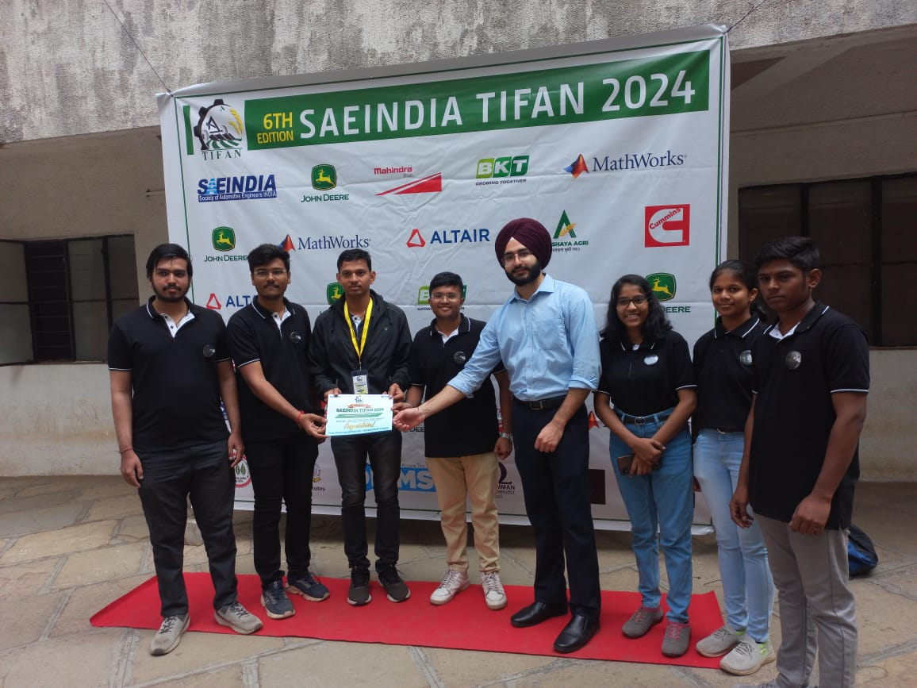Participating in the SAE India TIFAN competition at Sinhgad on December 27, our team excelled in Round 1, securing qualification and advancing to the finals.The

team's exceptional technical prowess, innovative solutions, and collaborative dynamics played a crucial role in this success.

As finalists, we now look forward to presenting our innovative ideas in the final round, confident in our ability to contribute meaningfully to the discourse on futuristic automotive technology. This accomplishment underscores our commitment to excellence and positions us as forward-thinking contenders in the competition.

**12) “Triumphant at Sevak Melawa 2024: Innovation Recognized, Excellence Celebrated":-**

The Mechagrinics team is thrilled to announce our recent success at Sevak Melawa 2024, where we were honored with a prestigious award presented by Tanaji Sawant Sir. Our groundbreaking project not only showcases innovation and technical excellence in mechanical engineering and robotics but also introduces a

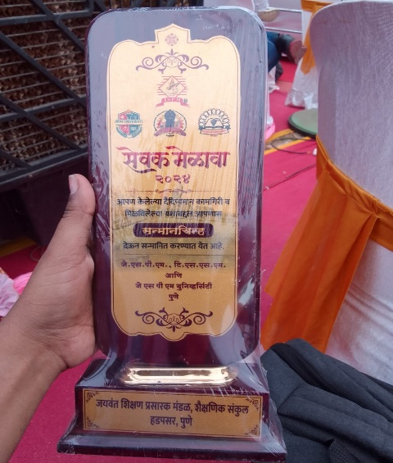

paradigm shift in the agricultural field through our innovision. This recognition not only celebrates our dedication and hard work but also highlights the potential impact of our solution in revolutionizing agricultural practices. Tanaji Sawant Sir's acknowledgment of our project underscores its significance, inspiring us to continue pushing boundaries and driving positive change in multiple industries.

**13) “Team Mechagrinics at Krushik Baramati: Pioneering Innovation in Agriculture":-**

The Mechagrinics team recently visited the Krushik event in Baramati, showcasing our pioneering innovations in agriculture. This event provided an invaluable platform to demonstrate our cutting-edge agricultural technologies and solutions to a diverse audience of industry experts, farmers, and technologists.

Engaging with other innovators and receiving feedback has further inspired us to refine our projects and explore new collaborations. Our participation at Krushik Baramati underscores our commitment to advancing agricultural practices through innovation and technological excellence, reinforcing our role as leaders in the field**.**

**14) "Team Mechagrinics: Finalists at InnoWave IIT Roorkee, Driving Innovation Forward!":-**

The Mechagrinics team is proud to announce that we have qualified for the final round of the prestigious InnoWave event organized by IIT Roorkee.

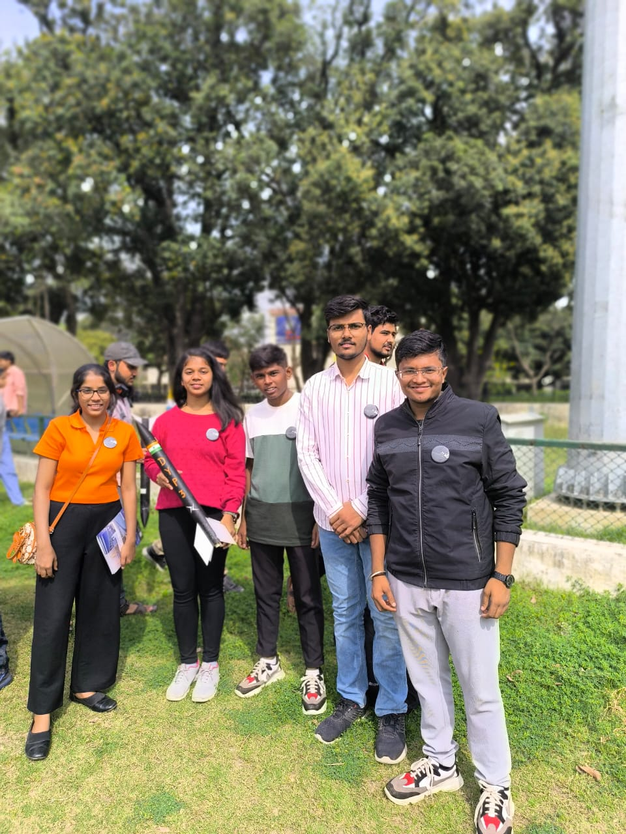

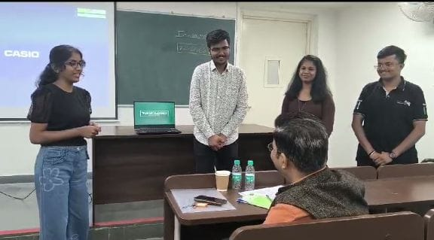This achievement highlights our innovative capabilities and dedication to excellence in technological advancements. Competing against top-tier teams from

across the country, our project has stood out for its ingenuity and potential impact.Reaching the finals at such a renowned event is a testament to our hard work and creativity**,** and we are excited to showcase our solutions on this esteemed platform. This milestone not only motivates us to push our boundaries further but also reinforces our commitment to driving innovation in our field.

**15) "Overcoming Challenges Together: United with College Support Through Financial Hurdles":-**

Our team was facing an unexpected financial crisis that delayed our project **(Automated Multi Vegetable Transplanter)** by 15 days, our team experienced a significant setback in morale and progress. However, our college stepped in with crucial financial support, allowing us to procure necessary materials, realign our timeline, and stabilize team morale. Additionally, the college provided mentorship and resource access which collectively helped us overcome the challenges. This experience highlighted the power of community and resilience, reinforcing our commitment to achieving our project goals despite obstacles.

**16) "Milestone1 : in Motion Launching TIFAN 24":-**

Top of Form